# Deployment Of App In IBM Cloud

|  |  |
| --- | --- |
| Project Name | Inventory Management System for Retailers |
| Team ID | PNT2022TMID52529 |
| Date | 18 NOV 2022 |

**TASK**

* Containerize the App
* Upload image to IBM Container Registry
* Deploy in Kubernetes Cluster

# Containerize the App

* + Docker image creation

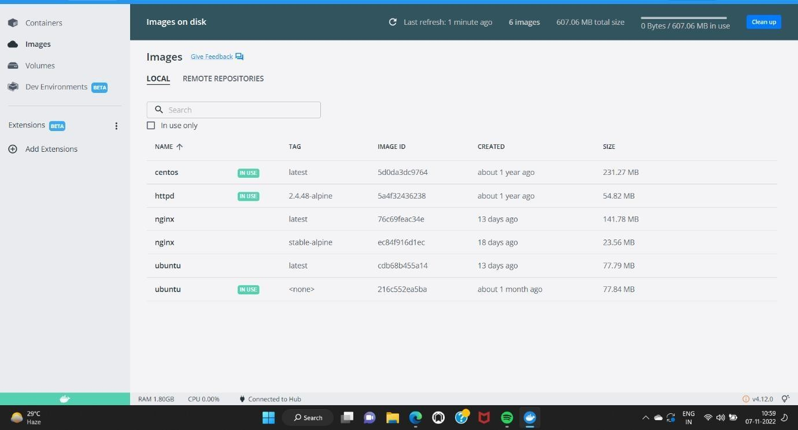

# Upload image to IBM Container Registry

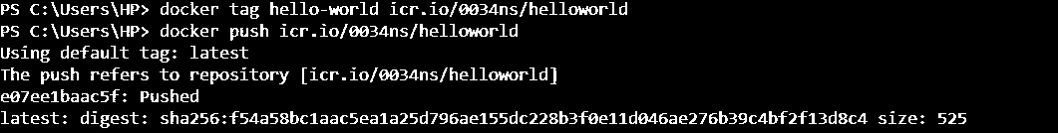

**Deploy in Kubernetes Cluster**

Deploy on kubernets

